Fit For Whom
  - Proven, Not Presumed — Part Five
By Mario Aiello | Adaptive Ways
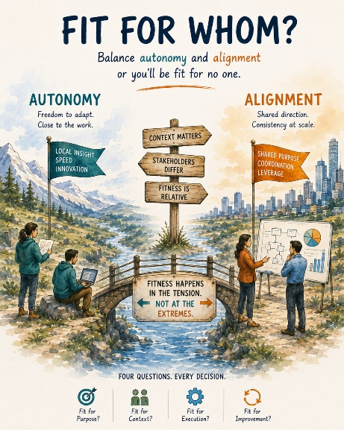
A team I worked with cut their release cycle from six weeks to under one. Genuinely impressive. Genuinely earned. Nobody told them to, nobody handed them a mandate, they just got good at their own local practice and shipped faster. Three months later, the support function two departments over was drowning, because a release cadence built for the team that wanted it had quietly become an operational shock nobody downstream had agreed to absorb. The team that caused it had done nothing wrong. That's what makes this one hard to fix by pointing fingers.
Call it the autonomy-alignment paradox. You need local autonomy for genuine adaptiveness — nobody two levels removed from the work can sense a changing context as fast as the people actually in it, and the whole promise of adaptive organizations is that the people closest to the friction get to act on what they see, without waiting for permission from somewhere slower. But autonomy without alignment doesn't stay contained. Every team optimizing brilliantly for its own context is, at the same time, exporting the consequences of that optimization to every team it touches, and none of them asked to be consulted. You can't get the speed of autonomy without the risk of exactly this kind of unannounced, well-intentioned collateral damage.
The paradox part isn't "sometimes autonomy goes wrong." It's that the more successfully a team practices real autonomy — the more genuinely well-matched to their own context their decisions become — the less visible the downstream effect gets, because good local decisions don't look like risks from the inside. They look like exactly what they are: someone doing their job well. Nobody audits a decision that's clearly correct for the team making it. That's precisely why it can travel two departments over before anyone notices.
Most agile thinking stops at the team boundary and calls the job done — autonomous team, fast feedback loop, ship it. That's necessary and nowhere near sufficient, because it never asks the question that actually catches this: fit for whom. Not fit in general. Not fit for this team's own goals, measured by this team's own yardstick. Fit for whom, specifically — which forces the question of who else is a stakeholder in a decision that, on paper, belongs entirely to one team.
That's why "Fit for Whom" sits inside the Four Questions for Fitness as its own question, not folded into "Fit for What" as an afterthought. Fit for What tells you the decision solves a real problem. Fit for Whom is the one that forces you to name every party the decision actually touches, not just the party making it — and naming that list is usually where the autonomy-alignment paradox stops being invisible, because most of the damage in these cases isn't subtle once you're forced to ask who's downstream. It's subtle only because nobody was required to ask.
This doesn't resolve the tension, and it shouldn't pretend to. You still need the team moving fast on their own read of their own context — slowing them down to check with everyone potentially affected defeats the entire point of autonomy. What Fit for Whom does is keep the question live rather than letting it quietly drop out of the sequence the way it does in most operating models, where "the team decided" is treated as the end of the analysis instead of the start of a second one.
The diagnostic question: whose fitness gets counted when we call this decision fit — and is there someone on that list who'd disagree with the answer if they'd been asked before instead of after.
That's the fifth. Which brings us back to the one underneath all of them.
—

