Proven, Not Presumed
  - Closing the series
By Mario Aiello | Adaptive Ways
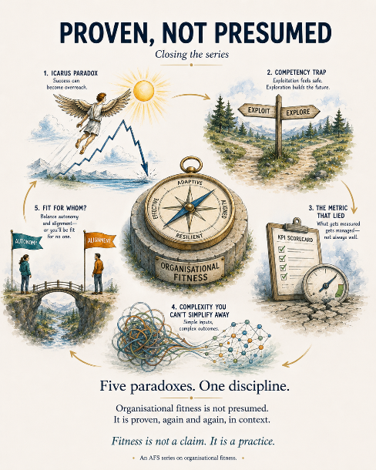
Five posts ago I told you I wasn't going to resolve something, and I wasn't lying, because it still isn't resolved. It's not supposed to be. That was the point.
Here's the paradox again, plainly: AFS exists to catch organizations presuming their own fitness instead of proving it. Which means AFS is itself a structure making fitness claims, and if the Governing Law is real — fitness is proven, not presumed — it has to apply here too, or the whole approach is just a framework that learned better manners. An approach that catches Icarus while quietly flying is not an approach. It's a slogan with a diagram.
Across the last five posts you watched this law catch other organizations in five different disguises. Success that outlived its context and nobody noticed the expiry date. Competence that narrowed the very judgment needed to see past it. A metric that got exactly what it asked for while the real thing went nowhere. A complexity problem with no fixed answer, only a right-now answer that keeps moving. A team doing its job so well the damage traveled two departments over before anyone thought to ask who else was affected. Different costumes. Same law, catching the same failure: mistaking "used to be true" for "still true."
So the honest question to close on isn't whether AFS is exempt from that. It isn't. The question is whether there's actual evidence — not a claim, evidence — that AFS gets tested against its own law rather than just gesturing at humility and moving on.
There is, and it's less glamorous than I'd like it to be, which is usually a good sign that it's real. Over time, working across the AFS material, terms drifted. The Fitness Sequence got described one way in one document and a slightly different way in another. Components of the FVI Lens picked up inconsistent labels depending on which piece I'd written them into. The Adaptive Engine sequence had language in circulation that didn't quite match itself paper to paper. None of this was a scandal. It's exactly what happens to any body of work that's used across enough contexts for long enough — the same quiet entropy Fit for Improvement exists to catch in a client's organization, except this time it was mine.
The response wasn't to quietly patch a word here and there and hope nobody compared documents. It was a full inventory — the whole corpus, roughly seventy-five documents, checked against itself, with an actual drift and terminology-violations register produced from the comparison, and a canonical spine established as the version that now governs everything downstream of it. That's Reverse Validation, run on AFS by AFS: not "does this feel consistent," but "here is the specific evidence of where it wasn't, named and logged, with a decision about which version is now the fit one going forward."
That's the difference this whole series has been circling. A framework would have called the drift a documentation issue and fixed it silently. An approach that means what it says about proving fitness has to surface the drift, log it, and let the correction be visible — because the alternative is presuming its own coherence instead of proving it, which is precisely the failure this entire series has spent five posts describing in other people's organizations.
I don't think that closes the paradox. I think it's supposed to stay open — the moment I'd tell you AFS has fully resolved its own fitness question is the moment it's stopped proving and started presuming, which is the one move this whole approach exists to catch. The best I can offer is that the checking is real, it's ongoing, and it's the same checking I'd ask of anyone I was advising. If that ever stops being true, the honest thing is to say so here, not to let the slide sit on the wall unexamined.
Fitness is proven, not presumed. Including this.
—

