DORA Tells You If You're Fast, Not If You're Fit
By Mario Aiello – Adaptive Ways

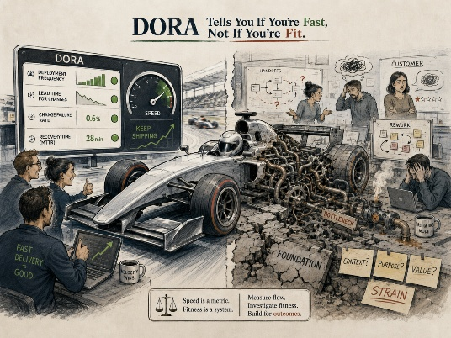
Deployment frequency, lead time for changes, mean time to recovery, change failure rate — four numbers, and an entire industry has agreed to treat them as the closest thing to an objective read on engineering health. Get them green and you've earned the right to stop asking harder questions. That agreement is doing more work than the metrics themselves.
DORA metrics are good at what they measure. They tell you how quickly a team can move a change from commit to production, and how quickly it can recover when that change breaks something. That's a real capability, and it's worth measuring. The trouble starts when the four green numbers get treated as a verdict on the system, rather than a reading of one layer of it.
In Adaptive Fitness System terms, DORA lives entirely inside Fit for Execution. It's an instrument for one step of the Fitness Sequence — the step that asks whether the mechanics of delivery are working. It has nothing to say about Fit for Purpose, which asks whether the thing being delivered so efficiently is still the right thing. It has nothing to say about Fit for Context, which asks whether the environment the system was built for still exists. And it has nothing to say about Fit for Improvement, which asks whether the organization is actually adapting or just running the same loop faster.
Put DORA through the Four Questions and the gaps are obvious. Fit for What — not answered. By Whom — not answered. Until When — not answered. How — answered, exhaustively. DORA is a very good instrument pointed at a quarter of the problem, mistaken by most rooms for a full physical.
This is exactly the failure mode the Friction-Fitness Map exists to catch. A team with four green DORA numbers and no Reverse Validation running back to purpose isn't necessarily in Stable Flow. It can just as easily be sitting in System Strain — high functional throughput, spent entirely on output nobody has re-checked against what the organization actually needs. From the dashboard, System Strain and Stable Flow look identical. The only way to tell them apart is to ask the question DORA was never built to ask.
None of this is an argument against measuring delivery speed. It's an argument against presuming that speed proves fitness. AFS's governing law cuts against exactly this habit: fitness is proven, not presumed. A green dashboard is a claim, not a proof. The proof is the loop back to purpose that most organizations skip, because the dashboard already made them feel finished.
–

