Green Dashboard, Wrong Building
  - EBM tells if work is producing value, not if it still belongs where you put it.
By Mario Aiello – Adaptive Ways

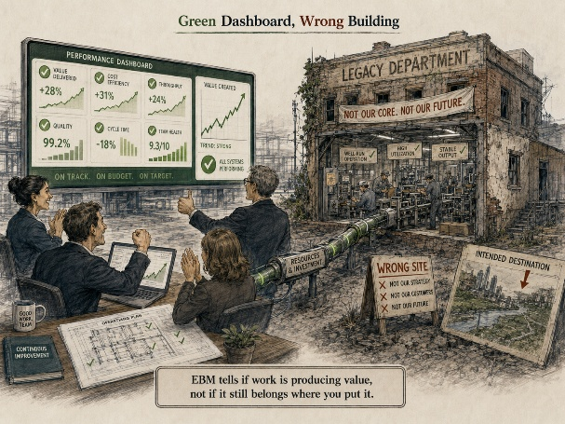
Every few years, someone in a Scrum.org webinar says the phrase "empirical process control" like it's a discovery. It isn't. It's just what happens when an organization finally admits it's been guessing.
Evidence-Based Management showed up to fix a very specific kind of guessing: teams that ran every ceremony correctly and still couldn't tell you if any of it mattered. So EBM gave people four numbers to stare at, current value, unrealized value, time-to-market, ability to innovate, and said, essentially, stop grading yourself on compliance and start grading yourself on output. Reasonable. Overdue, even.
Here's the thing nobody says out loud: EBM assumes the shape of the organization is already right, and just wants better instruments on the dashboard. It's asking "is this producing value." It is not asking "should this thing exist in this form at all." Those are different questions, and the second one is usually the more dangerous one to ask, which is exactly why nobody built a scorecard for it.
That second question is the one AFS starts with. The governing law is blunt about it: fitness is proven, not presumed. Not "fitness is scored quarterly." Proven, meaning if you can't point to the evidence right now, you don't get to claim the fit. Reverse Validation is the practitioner tool for that: you don't declare a structure correct because it matches the textbook, you go find out whether the system it's sitting inside actually confirms it. That's uncomfortable in a way EBM's dashboards never are, because a dashboard can go green while the underlying structure is still wrong for the organization it's attached to.
So if you're trying to place AFS next to EBM instead of underneath it: EBM measures whether what you're doing is producing value. AFS checks whether what you're doing still belongs in the system that's producing it. One is a value instrument. The other is closer to a fit test, asking fit for what, by whom, how, and until when, which are the kinds of questions a value dashboard was never built to answer.
None of this makes EBM wrong. It makes it partial, and partial is fine as long as you know which part you're missing. The failure mode is treating "our EBM numbers are healthy" as proof the org chart, the role definitions, or the operating model underneath them are still the right ones. They might not be. The numbers can be green right up until the moment the whole structure needs to change, and nothing in EBM is designed to warn you that day is coming.

