next LinkedIn article

Why Nobody Writes About ITIL and DevOps Anymore
  - An AFS view on how they both ended up
By Mario Aiello | Adaptive Ways

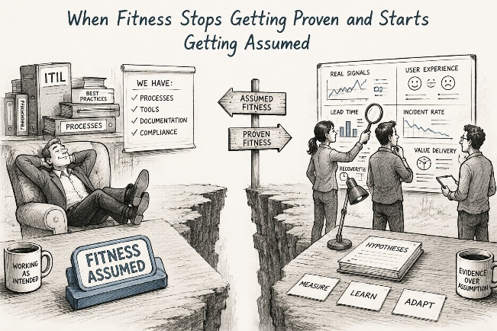
A few years back, every other transformation meeting had that slide. ITIL on one side, DevOps on the other, a Venn diagram squeezed in the middle labeled "synergy." ITIL people talking change advisory boards. DevOps people talking forty deploys a day. Everyone nodded, snapped a photo of the slide for later, went back to doing whatever they'd already decided to do. And then, at some point nobody can quite date, the whole conversation just stopped. No memo. No closing keynote. Just gone.

Worth sitting with that, because it's not the same kind of gone in both cases. ITIL didn't lose the argument and shake hands after. It lost so hard nobody bothers writing the obituary. DevOps didn't lose anything. It won so completely it stopped needing a name.

ITIL first, since it's the one that's harder to be fair to. Here's what people skip past: ITIL wasn't wrong when it got built. It was a sane answer to a world of long release cycles, hard infrastructure, change that was genuinely expensive and genuinely dangerous. Of course you'd want a board around that. Of course you'd want approvals and rollback plans in writing, signed. Nothing wrong with the thinking. What went wrong is the world it was built for quietly packed up and left, and nobody went back to check whether the practices still made sense without it. Change stopped being rare and expensive. ITIL kept acting like it still was.

Call that a failure to keep proving itself, not a failure of the original idea. ITIL never ran its own Reverse Validation — never went back and asked whether the assumptions under the change advisory board still held. It just kept running a pattern that used to be right, like correctness was something you earn once and get to keep. Saying that plainly means admitting ITIL was right for its moment and wrong for this one. Less satisfying than "ITIL was bureaucratic nonsense." Also the true version.

DevOps is the mirror image. Its disappearance is a compliment nobody's cashing in. It won so thoroughly — CI/CD, infrastructure as code, observability, the whole loop from production back into development — that it just became what competent engineering looks like. Nobody writes retrospectives about the fax machine either, not once everyone's just emailing. A win that total doesn't generate content. No crisis in it. No villain. Nothing to argue about at a conference. It just works, then disappears into "how we do things here."

Here's where the Fitness Sequence earns its keep — it holds both stories in one frame instead of two unrelated ones. Fit for Purpose: what was each one actually optimizing for. Fit for Context: did that purpose still match the world outside. Both of them lived for years in Fit for Execution — ITIL in its boards and gates, DevOps in its pipelines and dashboards. The real fork shows up at Fit for Improvement. DevOps built the retro loop into its own machinery and let it feed straight back up into Purpose. ITIL built that loop too, on paper — just never let it touch the assumptions sitting underneath the process.

Same question under both, though: fit for what, until when. Two completely different endings. One never re-proved itself and got quietly walked away from. The other proved itself so well it stopped even looking like a methodology. Neither story's really about ITIL or DevOps, when you get down to it. Both are about what happens when "fit" gets treated as something you settle once, instead of something you keep earning against a world that never agreed to hold still.

#AdaptiveFitness #DevOps #ITIL #OrganizationalDesign #AgileTransformation #ITSM #Leadership #ChangeManagement

