OKRs Were Never the Problem
  - An AFS view on the topic
By Mario Aiello – Adaptive Ways

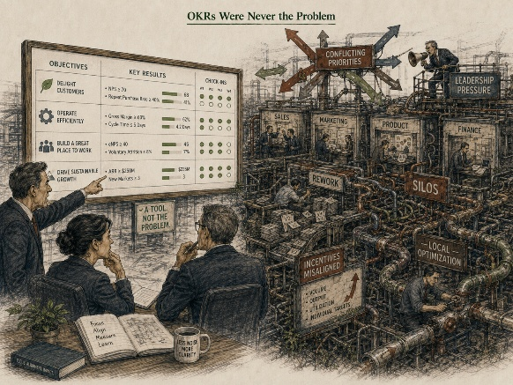
Every few years a management practice arrives with a real success story attached, and for once the story is true. OKRs have one. Andy Grove built the thing at Intel to solve a specific problem — how to connect ambition to something measurable without either drowning in vague inspiration or shrinking into a task list. Google took it on early, under John Doerr, inside a culture small enough and honest enough to run it the way it was designed: objectives set close to the work, key results owned by the people doing the work, nothing tied to compensation, and a check-in rhythm tight enough that drift got caught in weeks, not quarters.
That's not folklore. That's a method that was genuinely, demonstrably fit for its context. Which makes what happens next more interesting than the usual story of a framework failing on its own merits, because this time the method didn't fail. The adoption did.
You've seen the version that goes wrong. Somewhere between the case study and the rollout, key results get quietly wired into the performance review. Objectives stop surfacing from the work and start cascading down from a strategy deck. The count creeps from a handful to a dozen because no one wants to say a team's contribution doesn't need its own line item. Scoring turns into a reporting ritual — a color, a percentage, a slide — instead of the sensemaking exercise it was built to be. None of that is OKRs malfunctioning. It's OKRs being run without a single one of the conditions that made them trustworthy in the first place.
This is the part AFS is built to catch, because the approach doesn't ask whether a method is good. It asks whether fitness has actually been established here, for this organization, under these conditions — and it has four blunt questions for finding out: fit for what, by whom, how, and until when.
Fit for what is usually where the trouble starts. Most organizations bring in OKRs to solve a communication problem — shared priorities, visibility, some sense of what actually matters this quarter — and then operate them as a performance-measurement system instead. Those aren't the same job, and a method built for one doesn't automatically do the other. The moment key results start feeding into someone's review, the sensemaking tool has been reassigned to score-keeping, and score-keeping is exactly what breaks the honesty the method depends on.
Fit for whom asks whether the team setting the key results actually owns them, or is receiving them. The Intel and Google versions presumed a level of trust and local ownership that has to be built, not assumed. Where objectives get handed down instead of set by the people closest to the work, the method is missing the one ingredient that made it worth copying.
Fit for how is the cadence question, and it's the one most adoptions quietly drop. The discipline underneath OKRs was never the quarterly template — it was the weekly check-in that kept the objective honest in real time. Keep the quarterly ritual, lose the weekly discipline, and you've kept the calendar and thrown away the mechanism.
Fit until when is the one nobody asks, because it implies the method might eventually not be needed in its current form. OKRs were built to build a muscle — a shared discipline about connecting ambition to results. An organization that's actually internalized that shouldn't need heavier and heavier OKR infrastructure over time; it should need less. A program that only ever entrenches, never lightens, is telling you the fitness was never established. Only the ritual was.
What makes OKR misuse worth its own entry in this series, rather than just another case of borrowed fitness, is where it tends to hide. It doesn't show up as visible friction — nobody's fighting about it, nothing's on fire. It lands almost every time in Hidden Misfit: the quarterly cycle runs on schedule, the dashboard fills in green and amber right on cue, every visible signal says the process is healthy. The friction is that none of it is doing what OKRs exist to do. Ask a team how aligned they feel and how much they trust the number on the slide, and you'll usually get two very different answers — and the second one almost never makes it into the reporting the process itself produces.
The corrective isn't a better rollout deck. It's Reverse Validation — instead of auditing whether OKRs are being run correctly, ask what the organization can actually point to as a result of running them. If the honest answer is a stack of completed templates rather than any real shift in how priorities get set and resourced, you haven't implemented OKRs. You've implemented the paperwork OKRs leave behind.
Which is really the whole point of this one. OKRs are the cleanest version of the AFS Governing Law you're likely to find in the wild: a method can be proven, in its own right, in its own context — and still get adopted on presumption everywhere it travels next. The fitness that made it worth copying was never in the template. It was in the conditions around it. Fitness is proven, not presumed, and that applies just as much to the practices we borrow because they worked somewhere else as it does to anything we build ourselves.

