The Crocodile's Contract
  - What an Ancient Paradox Says About How Organizations Validate Fitness
By Mario Aiello – Adaptive Ways

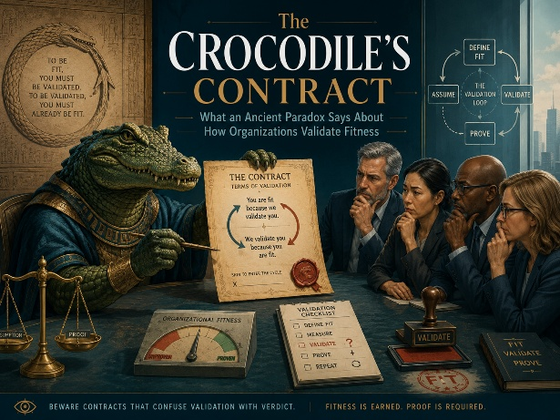
A Friction-Fitness Map paper – leveraging the Crocodile Paradox

A crocodile snatches a child from a riverbank. The mother begs for the child back. The crocodile, being a crocodile with unusually strong opinions about logic, offers a deal: "I will return your child if, and only if, you correctly guess what I am about to do."
The mother says: "You will not return my child."
Now the crocodile is stuck. If it returns the child, her guess was wrong, which means the condition for returning the child was never met — so it shouldn't have returned the child. If it eats the child, her guess was right, which means the condition for returning the child was met — so it has to return the child. Either move it makes violates the rule it just set for itself.
This is the Crocodile Paradox, and it has survived over two thousand years not because anyone has resolved it, but because it names something real: a validation rule that references its own outcome will eventually collapse under its own weight. The crocodile didn't get outsmarted by a clever mother. It got caught by the structure of its own contract.
Organizations set crocodile contracts constantly. They just don't notice the teeth until later.

The self-referential trap, in a boardroom
Here is the pattern, stripped of reptiles: a leadership team defines success for a transformation as "the point at which the organization believes the transformation is working." Or a governance board approves a program on the condition that "confidence in the program increases." Or a change initiative is deemed validated when "stakeholders feel it has been validated."
Each of these looks like a criterion. None of them is one. The thing being measured and the thing doing the measuring are the same thing, and a system cannot certify its own fitness by consulting only its own opinion of itself. This is not a minor design flaw you can patch with a better dashboard. It is structurally identical to the crocodile's promise — the condition for the outcome depends on an assessment that only exists after the outcome has already happened, or that changes the moment it's invoked.
Under AFS Governing Law, this failure is precisely what "fitness is proven, not presumed" was built to catch. Presumed fitness is what the crocodile is offering the mother: a rule that sounds rigorous, resolves nothing, and lets the crocodile decide after the fact which version of events was true all along. Proven fitness requires the criterion to sit outside the thing being judged — an external, falsifiable check that doesn't move depending on which answer you'd prefer.

Why Reverse Validation is the way out
The mother in the story is usually treated as the clever one, and she is — but notice what she actually did. She didn't try to out-argue the crocodile's logic. She built a guess that made the crocodile's own rule the mechanism of its failure, regardless of which way it moved. She stopped asking "will you keep your promise" and instead asked "what does this promise actually commit you to, structurally, no matter what you do next."
That's Reverse Validation. Instead of asking a transformation "do you feel like you're working," you ask what would have to be true, externally and independently, for the claim of fitness to survive contact with reality. You go looking for the condition that breaks the presumption, not the condition that confirms it. A transformation that's only ever been asked to confirm itself is a transformation that has never been tested — it has only been consulted.
This is also why AFS insists that Fitness be assessed through Fit for What, by Whom, How, and Until When, rather than through a single self-referential temperature check. Each of those four questions forces the criterion outside the system being assessed. "Fit for what" names an external purpose the system doesn't get to redefine mid-assessment. "By whom" names a judge who isn't the system judging itself. "Until when" puts an expiry on the claim, so fitness can't be presumed to hold forever just because it held once. Strip any one of the four out, and you've quietly handed the system back its own crocodile contract — a rule it gets to interpret however keeps it fed.

The quadrant crocodiles like best
Run this through the Friction-Fitness Map and the crocodile has a clear favorite habitat: Hidden Misfit. This is the quadrant where things look calm on the surface — no visible friction, no one screaming that the system is broken — precisely because the validation criterion has been quietly rigged to never say no. Nobody has to confront a hard answer because the question was built so that only one answer was ever possible. That's not Stable Flow. Stable Flow has actually been tested and held. Hidden Misfit has just never been asked a question it could fail.
System Strain and Adaptive Tension, by contrast, are what you get when an external, non-negotiable criterion is actually in play and the system is straining against it or adapting to meet it. That strain is uncomfortable, and it is also the only kind of validation signal that means anything. The crocodile's contract feels safe. It is actually the least informative position a system can occupy, because it was designed to never resolve.

The practitioner's version of the mother's move
The mother's guess is worth stealing wholesale as a diagnostic habit. Next time a stakeholder group tells you a program will be judged as fit "once confidence improves," or "once the team feels aligned," or "once leadership is satisfied," ask the crocodile's question back: what happens if the answer is no? If there is no version of the criterion under which the system could fail — if every possible outcome gets quietly reinterpreted as success — you are not looking at a validation criterion. You are looking at a promise with the mother's guess still unasked.
Fitness-Driven Design starts exactly there: build the falsifying condition before you build the initiative, not after. Decide, in advance and outside the system's own vote on itself, what would count as evidence the approach doesn't fit — Fit for Purpose failing, Fit for Context breaking, Fit for Execution stalling, Fit for Improvement never showing up. Only once that condition exists independent of the system's mood can Reverse Validation actually run against it.
The crocodile never had to keep its promise, because the promise was built so that keeping it and breaking it looked identical from the inside. Most organizational validation is built the same way, usually by accident, always by people who genuinely believe they've set a real bar. Fitness that is proven, not presumed, is the discipline of noticing the difference before the river closes over it.

© Mario Aiello | Adaptive Ways

