Nobody Brought In a Consultant This Time
  - Presumed Fit II: The Insurance Edition – Part Two
By Mario Aiello | Adaptive Ways

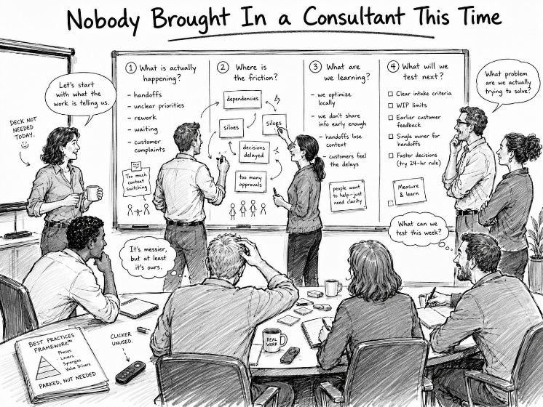

At the previous client, someone else's answer had been installed and mistaken for a diagnosis. At this one, there was no answer to mistake for anything, because nobody had gotten as far as asking the question. There was no external firm this time, no imported method, no slide deck with a mountain on it. There was just a very dense, very controlled political environment that had never quite worked out what agility was, and had been getting along fine — or getting along, at least — without finding out.
This is a different kind of presumption, and it took me longer to see it than before, because it doesn't announce itself with ceremonies. Nobody was running fake Scrum. Nobody was burning down anything. What was running instead was the organization's normal operating logic: decisions moved through the political structure the way decisions always had, control was distributed the way it had always been distributed, and "agile" existed mostly as a word people used in meetings without anyone being especially sure what would change if you took it seriously.
The presumption here wasn't that a method was fit. It was that the current setup was fit — that the absence of an explicit agility conversation meant there was nothing to fix, rather than meaning the friction had simply never been named. In a dense political environment, that's not an accident. Naming friction means naming who's causing it, and that has a cost nobody was volunteering to pay. So the friction didn't disappear. It went underground, and the org kept functioning at a level just above where anyone had to look at it directly.
That's Hidden Misfit, and it behaves nothing like System Strain. Strain is visible if you know where to look — velocity charts and ceremony theater practically invite inspection. Misfit hiding inside political control invites nothing. It's stable, in the way a load-bearing wall with a hairline crack is stable, right up until it isn't. Everyone in the room can sense that coordination is harder than it should be, that decisions take longer than the work justifies, that initiatives quietly stall without anyone being blamed for stalling them — and still describe the setup as functioning, because functioning and healthy get treated as the same word when naming the gap is politically expensive.
The Four Questions don't get you into this kind of environment by asking them out loud. Fit for what, fit for whom, fit for how, fit for until when — asked directly, in a room that dense, they read as an audit, and an audit is exactly what a controlled political environment is built to deflect. The actual work was slower and less visible than the first engagement: finding the places where the questions were already being asked informally, in corridor conversations and deflected agenda items, and giving management a way to see the answers without forcing anyone to stage a confrontation to get them.
What made this fit-for-purpose work possible wasn't introducing agility as a new vocabulary. It was showing that the misfit already existed, had a shape, and was costing something specific — which is a very different move from arriving with a method and asking people to adopt it. You can't fix Hidden Misfit by installing anything. You have to make it visible enough that continuing to presume fitness becomes more expensive than admitting there wasn't any.
Next: where the problem wasn't an absent method or a hidden one — it was a method everyone had memorized and nobody had checked on in years.

