The Flag That Got Overruled
  - The playbook was right. The quadrant was wrong.
By Mario Aiello – Adaptive Ways
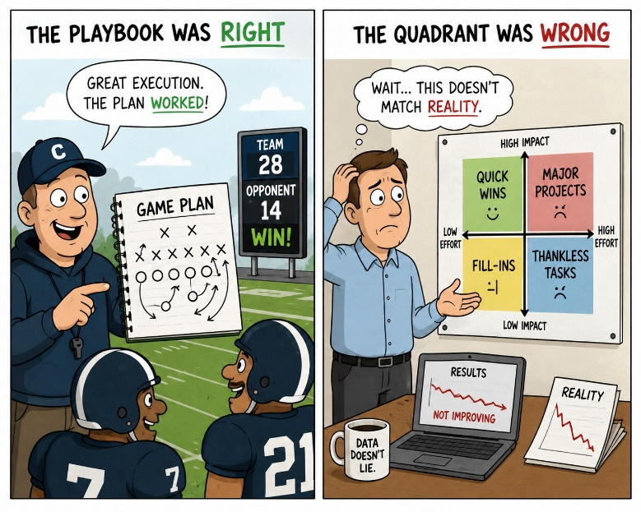
Second paper of the Presumed Fit Series*

Somewhere in the middle of a large agile transformation, someone in the business raised a hand.
The operating model had been lifted more or less whole from another bank — same tribe structure, same ceremony cadence, same role titles, same maturity model to track progress against. It had visibly worked somewhere else. Somebody senior had seen it, liked what they saw, and brought it back. The person raising the flag wasn't objecting to agile. They were pointing out that this particular model assumed a product structure and a funding cycle this bank didn't have, and that forcing teams into it was going to produce the appearance of the model without the substance — squads with the right names, running the right ceremonies, still reporting into the same command chain that made the ceremonies decorative.
The response was polite and final. The model had been endorsed by the board as the transformation's blueprint. It had a maturity assessment attached to it, with dates. Adjusting it now, before a single tribe had even stood up, would look like the transformation losing its nerve before it started. The concern got noted, folded into "lessons learned as we scale," and the rollout proceeded on schedule.
Eighteen months later, the maturity assessment showed strong scores — most tribes had adopted the ceremonies, most roles were filled, most dashboards were green. And underneath the dashboards, the actual funding and reporting lines hadn't moved at all. Decisions still traveled up the old chain and back down; the squads had absorbed the vocabulary and changed almost nothing about how authority worked. It surfaced as an incident of its own — a board-level review asking why two years and a significant budget had produced so little change in outcomes — and the fix proposed was a second transformation, this time promising to address "the parts that didn't stick," funded to repair what the first flag had already described before a single team was formed.
The easy read is that leadership made a bad call under launch pressure. I don't think that's what happened, and I don't think it's what usually happens. What happened is more specific: the flag got filed under the wrong heading. It was read as resistance — the ordinary discomfort you expect whenever a large organization is asked to work differently — and every transformation playbook has a well-worn answer to that heading. Hold the line, communicate the vision, bring people along. So that's what happened. The one problem with applying that answer here is that the flag wasn't resistance to change. It was a structural read of why this particular change, in this particular shape, wasn't going to fit.
AFS draws that distinction on the Friction-Fitness Map, and the two quadrants are easy to confuse from the inside precisely because they feel identical in the moment. Adaptive Tension is the discomfort of a structure being tested against real conditions for the first time — it's supposed to be uncomfortable, and pushing through it is usually correct. System Strain is friction from something that doesn't fit the structure it's being forced into — a model built for a different funding cycle, a different reporting line, a different bank, now grinding against a reality it was never built to hold. Pushing through System Strain doesn't produce adaptation. It produces exactly what happened here: the form without the substance, because the mismatch was never structural noise to power past — it was an accurate diagnosis of a fit problem, delivered early, for free, by someone who'd actually looked.
The board and the transformation office weren't negligent. They had a well-run playbook for managing Adaptive Tension — hold the line, protect the timeline, don't let early friction dilute a bold model. That playbook is often the right one. It is the wrong one here, because it was applied to the wrong quadrant, and nothing in the transformation's governance was built to ask which quadrant it was looking at before reaching for the standard answer. Suppressed System Strain doesn't resolve because you held the line on it. It goes underground, gets absorbed into the vocabulary and the dashboards, and comes back later as a board asking why two years of visible activity produced so little actual change — at which point everyone treats it as new information about the transformation. It wasn't new. It was the same flag, filed under the wrong heading, still waiting to be read correctly.
The uncomfortable implication isn't that this board was worse than most at telling the two apart. It's that almost no transformation governance is built to ask the question at all before defaulting to "hold the line." Every large change program running today has some version of the same single instinct: friction near the start reads as resistance, and resistance gets managed, not investigated. Until there's a live question — is this Adaptive Tension we should push through, or System Strain telling us the model doesn't fit — the next person who raises an early flag will get the same encouraging, final answer, and the review two years from now will read like a surprise it never actually was.

#AdaptiveFitness #AgileTransformation #OrganizationalDesign #AdaptiveWays #FrictionFitness #ChangeManagement #FinancialServices #LeadershipPractice

* Presumed Fit — three stories from European banking, each one an organization mistaking a passing grade on one narrow question for actual fitness.

