The Program That Fixed What It Was Asked to Fix
  - It closed the gap it was measuring. It never asked if that was the only one that mattered.
By Mario Aiello – Adaptive Ways
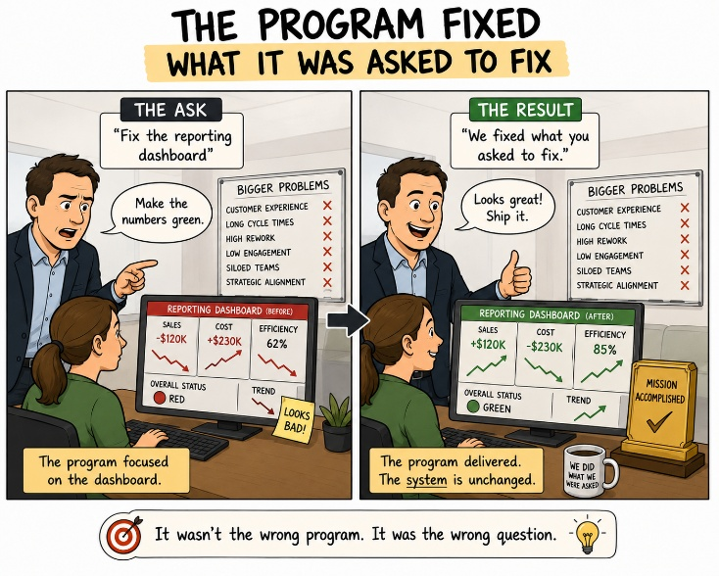
Third and last paper of the Presumed Fit Series*

There's a version of this story where the program is the villain, and it's the wrong version, because the program did exactly what it was built to do.
The bank ran a large delivery model split across an in-house team and an offshore team, and a regulator eventually noticed that the two sides weren't governed the same way — different reporting lines, different definitions of done, different evidence trails for the same work. A program was stood up to close that gap. It did. Within a year, both sides ran the same ceremonies, reported against the same metrics, sat under the same governance framework, and could produce identical audit evidence regardless of which office the work had happened in. Every question the program was built to answer, it answered. The regulator was satisfied.
What nobody had asked, because nobody had been asked to ask it, was whether the two teams could actually work together once they were forced into identical process. They could not, or not well. The offshore team started treating ceremonies as reporting obligations to survive rather than working sessions to use, because that's what the governance layer had effectively turned them into. The in-house team started treating the offshore team's contributions as compliance artifacts rather than engineering input, because the artifacts were now indistinguishable from what a governance dashboard wanted to see. Trust between the two sides, which had been mediocre but functional before the program, got worse. Delivery slowed. Rework rose. Two years in, someone senior looked at the numbers, correctly saw that both effectiveness and efficiency had declined since the transformation, and drew a conclusion: agile doesn't work for us. The model was quietly wound back toward something more centrally controlled, and the case became institutional lore — proof, repeated at conferences and in steering packs, that the approach itself was the problem.
It wasn't. The approach was never actually tested, because the program only ever asked one fitness question, and everyone mistook a passing grade on that question for a passing grade overall.
AFS has a structure for exactly this gap: the Four Questions for Fitness — fit for what, by whom, how, and until when. The program asked, rigorously, "fit for what" — fit for the regulator's requirement that both teams be governed consistently — and it answered that question well. It never asked "fit for whom." It never asked whether a governance structure built to satisfy an external regulator was also a structure two teams, separated by geography, language, and working hours, could actually collaborate inside of. Those are not the same question, and a good answer to the first tells you nothing about the second. The program's own dashboards were the proof: every governance metric held steady or improved for two straight years while the relationship it was supposedly enabling quietly came apart underneath it.
This is Hidden Misfit on the Friction-Fitness Map — the quadrant that's the hardest to catch, because it doesn't announce itself as friction. Friction is loud. It shows up in tickets and escalations and someone raising a hand in a steering committee. Hidden Misfit is quiet by construction: fitness looks fine on the axis you're measuring, and is deteriorating on an axis nobody built a dashboard for. The program wasn't lying about its numbers. Its numbers were real, and they were also answering a question narrow enough to miss the thing that was actually breaking.
The "agile doesn't work for us" conclusion is what happens when Hidden Misfit finally surfaces and gets attributed to the nearest available cause. The approach was standing closest to the wreckage when the relationship failure became visible, so the approach took the blame. What actually failed was scoping — a program that answered a real, regulator-facing fitness question thoroughly and never checked whether that was the only fitness question that mattered. It wasn't. The uncomfortable lesson isn't "measure more things." It's that closing one gap, however well, tells you nothing about the gaps you didn't think to look for — and an organization that mistakes the first for the second will keep discovering its Hidden Misfits the same way this one did: as a conclusion about the approach, arrived at two years too late, about a question the approach was never actually asked to answer.

#AdaptiveFitness #HiddenMisfit #AgileTransformation #AdaptiveWays #OrganizationalDesign #FrictionFitness #FinancialServices #OffshoreDelivery

* Presumed Fit — three stories from European banking, each one an organization mistaking a passing grade on one narrow question for actual fitness.

