The program that worked
  - Fitness is proven, not presumed. Most compliance programs settle for presumed.
By Mario Aiello – Adaptive Ways
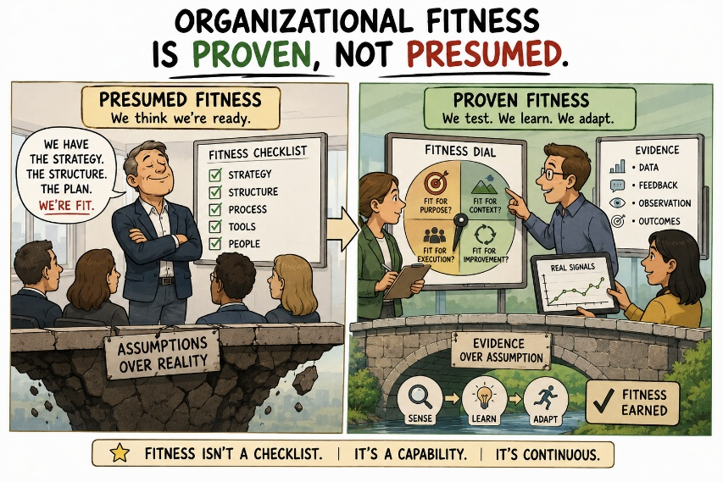
First paper of the Presumed Fit Series*
Every large bank I've worked with has run a regulatory change program that hit every milestone, passed every audit, and closed on time. Steering committee happy. Sponsor promoted. Slide deck archived as a template for the next one.
Nothing changed.
Not nothing in the sense of no output — there was plenty of output. New policy documents. New training modules, completed and logged. New control descriptions, mapped to new risk taxonomies, signed off by three lines of defence. A tracker with two hundred and forty line items, all green. By any measure the program was built to be measured against, it succeeded.
What it didn't do is touch how anyone in the business actually made decisions on a Tuesday afternoon. The underwriter still used the same judgment she'd always used, now with an extra form attached to it. The desk still ran the trade the way it always had, now with a compliance sign-off bolted on after the fact rather than before. The behavior the regulation was written to change was, a year later, unchanged. What changed was the paperwork sitting on top of it.
This is not a story about bad actors or lazy compliance teams. Everyone involved worked hard and meant it. That's what makes it worth looking at closely — it's not a failure of effort, it's a failure of what the program was allowed to count as fitness.
The Adaptive Fitness System (AFS) has a name for this now: Fitness-Washing. It's what happens when an organization substitutes the appearance of fitness — the audit trail, the milestone chart, the control library — for the thing itself, and does so sincerely, without anyone deciding to deceive anyone. The Governing Law of AFS is blunt about the alternative: fitness is proven, not presumed. A regulatory program that hits its milestones has proven that it can hit milestones. It has not proven fitness. Those are different claims, and the entire discipline of regulatory change management, as it's typically run, does not distinguish between them.
The tell is always the same. Ask the program what question it was answering, and the answer is some version of "did we implement the requirement." That's a real question. It's just not the question that determines whether anything changed. The question that determines that is closer to: does the underwriter's Tuesday-afternoon judgment now differ from what it would have been without this program? Almost no regulatory change program is instrumented to answer that. Most aren't even aware it's a separate question.
This is where Reverse Validation earns its keep, and where most programs quietly decline to use it. Reverse Validation doesn't ask whether the control was implemented. It asks the control to prove, after the fact, that it's doing what it was built to do — against actual behavior, not against the design document. Run that question against the program I'm describing and the answer arrives fast, and it isn't flattering. The control existed. It changed nothing it was supposed to change. Both of those things were true at the same time, for a year, while every dashboard said green.
None of this means the program should have been run differently in some obvious way — more time, better sponsorship, a smarter consultant. The people running it were optimizing correctly for what they were being measured against. That's the actual problem. The organization built a fitness question — did we implement the requirement — that was answerable, auditable, and completely disconnected from the fitness question that mattered. Everyone then did excellent work answering the wrong question.
If there's a practical takeaway, it's not "run more audits." It's that regulatory change programs need a second, harder question sitting alongside the implementation tracker from day one — not bolted on afterward as an impact assessment nobody reads. Something closer to: what decision, made by which role, on which day, should now go differently — and how will we know if it doesn't. Most programs can't answer that question when they start. Fewer still can answer it when they finish. That gap is where the compliance theater lives, and it survives specifically because nobody in the room is being asked to close it.

#AdaptiveFitness #FitnessWashing #RegulatoryCompliance #AdaptiveWays #OrganizationalDesign #ReverseValidation #FinancialServices #LeadershipPractice

* Presumed Fit — three stories from European banking, each one an organization mistaking a passing grade on one narrow question for actual fitness.

